***************************************************************************************
KUBEBYTES INTERNAL EXAMINATION 2026 ON AWS AND DEVOPS TOOLS Day - 02
***************************************************************************************

### Java / Maven / GitHub

- How can you create 5 JAR projects using Maven?
Step-1 : Open Command prompt
Step-2 : Install Java and Maven
Step-3: Check the versions
Step-4: Create a jar application using the below command(repeat 5 times, changing the artifactId)
mvn archetype:generate -DgroupId=com.kubebytes -DartifactId=my-app-01 -DarchetypeArtifactId=maven-archetype-quickstart -DarchetypeVersion=1.5 -DinteractiveMode=false
Step-5: Now run the maven build in goals inside the my-app-01 project to create a .jar file inside the target folder

- How can you create 5 WAR projects using Maven?
Step-1: Open terminal or Command Prompt.
Step-2: Navigate to workspace directory.
Step-3: Run the generation command for each project (repeat 5 times, changing the artifactId):
mvn archetype:generate -DgroupId=com.mycompany.app -DartifactId=my-webapp -DarchetypeArtifactId=maven-archetype-webapp -DarchetypeVersion=1.5 -DinteractiveMode=false
Step-4: Navigate into the project folder: cd my-webapp.
Step-5: Run the build command to generate the WAR file: mvn package

- How do you create 5 GitHub repositories for standalone Java projects?
Step-1: Log in to the GitHub account.
Step-2: Click the New repository button to create repository.
Step-3: Enter the name Stand-Alone-Java-Pro, set it to Public/Private, and click Create repository.
Step-4: Repeat this process 4 more times until I have 5 distinct URLs.

- How do you create another 5 GitHub repositories for web (WAR) projects?
Step-1: Log in to the GitHub account.
Step-2: Click the New repository button to create repository.
Step-3: Enter the name Web-Application-Project, set it to Public/Private, and click Create repository.
Step-4: Repeat this process 4 more times until I have 5 distinct URLs.

- How can you modify the `index.jsp` file in the given projects?
Step-1: Navigate to the web project folder.
Step-2: Go to src/main/webapp/ directory.
Step-3: Open index.jsp using a text editor vi command, eg: vi index.jsp .
Step-4: Modify the HTML content inside the <body> tags but clicking ‘i’ .
Step-5: After editing click on esc button and write :wq to save the content inside the file.
Step-6: Then run mvn package to include the changes in the new WAR file.

- How do you push Java code to GitHub repositories?
Step-1: Inside your local project folder, initialize Git: git init
Step-2: Add all files: git add ..
Step-3: Commit the changes: git commit -m "Initial commit".
Step-4: Link to the GitHub repo: git remote add origin https://github.com/gprasad-dev/Java-Monitoring-Project.git.
Step-5: Push the code: git push -u origin main (this is only for the first push)

- After deleting everything locally, how do you clone the project again from the central repository?
Step-1: Open the git bash terminal.
Step-2: Copy the URL of the repository from GitHub.
Step-3: Run the command: git clone https://github.com/gprasad-dev/Java-Monitoring-Project.git.
Step-4: Navigate into the newly created folder: cd Java-Monitoring-Project

- How do you execute Maven goals (`mvn clean install/package`) after cloning?
Step-1: Ensure first to be inside the project folder containing the pom.xml file.
Step-2: Run mvn clean to remove any old build artifacts.
Step-3: Run mvn package to compile the code and create the JAR/WAR file.
Step-4: Verify the output in the newly created target/ folder.

- How do you deploy and run a packaged WAR file on Apache Tomcat?
Step-1: Locate the generated .war file in the target/ folder.
Step-2: Copy the .war file.
Step-3: Navigate to the Tomcat installation directory and open the webapps/ folder.
Step-4: Paste the .war file into webapps/.
Step-5: Start Tomcat , to start the Tomcat go inside the bin folder and double click on startup file
Step-6: Access your app in a browser at http://localhost:8080/my-webapps.

### AWS / EC2 / AMI / Windows
10. How do you create your own AMI (Amazon Machine Image) in AWS?
Step-1: Log in to the AWS Management Console and go to the EC2 Dashboard.
Step-2: Select the Running Instance if the instance is already running or lunch a new EC2 Instance.
Step-3: Click on Actions > Image and templates > Create image.
Step-4: Enter an Image name and Description.
Step-5: Click Create image. AWS will shut down the instance (unless I select "No reboot"), take a snapshot, and store it under the AMIs section in the left sidebar.

- How do you launch a Windows EC2 instance?
Step-1: In the EC2 Dashboard, click the Launch instance button.
Step-2: Give the instance a name My-Windows-Server
Step-3: Under Application and OS Images, select Windows and choose a "Free tier eligible" version (like Windows Server 2022).
Step-4: Choose an Instance type t2.micro for free tier
Step-5: Select or create a Key pair (.pem or .ppk) and ensure Allow RDP traffic is checked in the Security Group settings.
Step-6: Click Launch instance.

- How do you connect to a Windows machine using the RDP protocol?
Step-1: In the EC2 Dashboard, click the Launch instance button.
Step-2: Give the instance a name My-Windows-Server
Step-3: Under Application and OS Images, select Windows and choose a "Free tier eligible" version (like Windows Server 2022).
Step-4: Choose an Instance type t2.micro for free tier
Step-5: Select or create a Key pair (.pem or .ppk) and ensure Allow RDP traffic is checked in the Security Group settings.
Step-6: Click Launch instance.
Step-7: Wait for the instance state to show Running and "Status check" to show 2/2 checks passed.
Step-8: Select the instance and click the Connect button at the top.
Step-9: Go to the RDP client tab and click Get password.
Step-10: Upload the Key Pair (.pem) file and click Decrypt Password. Copy the decrypted password.
Step-11: Download the Remote Desktop File provided on that same screen.

13. How do you launch a Windows VM using Remote Desktop Connection?
Step-1: In the EC2 Dashboard, click the Launch instance button.
Step-2: Give the instance a name My-Windows-Server
Step-3: Under Application and OS Images, select Windows and choose a "Free tier eligible" version (like Windows Server 2022).
Step-4: Choose an Instance type t2.micro for free tier
Step-5: Select or create a Key pair (.pem or .ppk) and ensure Allow RDP traffic is checked in the Security Group settings.
Step-6: Click Launch instance.
Step-7: Wait for the instance state to show Running and "Status check" to show 2/2 checks passed.
Step-8: Select the instance and click the Connect button at the top.
Step-9: Go to the RDP client tab and click Get password.
Step-10: Upload the Key Pair (.pem) file and click Decrypt Password. Copy the decrypted password.
Step-11: Download the Remote Desktop File provided on that same screen.
Step-12: Open the Remote Desktop Connection app on local Windows PC.
Step-12: In the Computer field, paste the Public IPv4 address or Public DNS of the EC2 instance.
Step-13: Click Connect. When prompted for credentials, enter the username (usually Administrator).
Step-14: Paste the Decrypted Password obtained from the decryption
Step-15: Click OK and accept the certificate warning to view Windows Server desktop.

### Frontend Deployment
14. How do you deploy a React project?
Step-1: Open your terminal inside the React project folder.
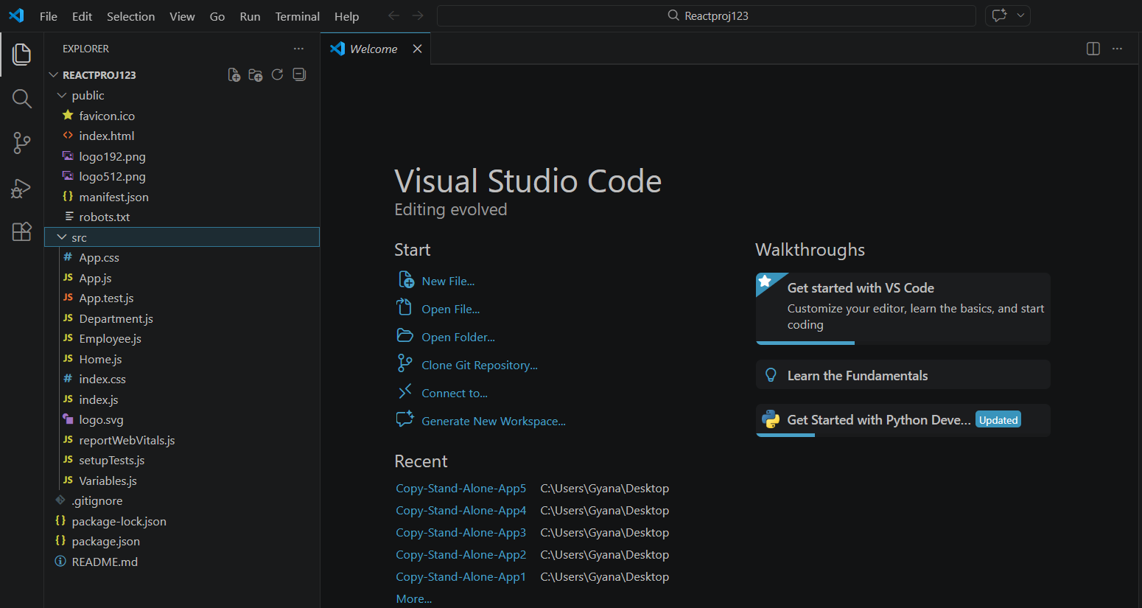
Step-2: Install the dependencies using npm install.
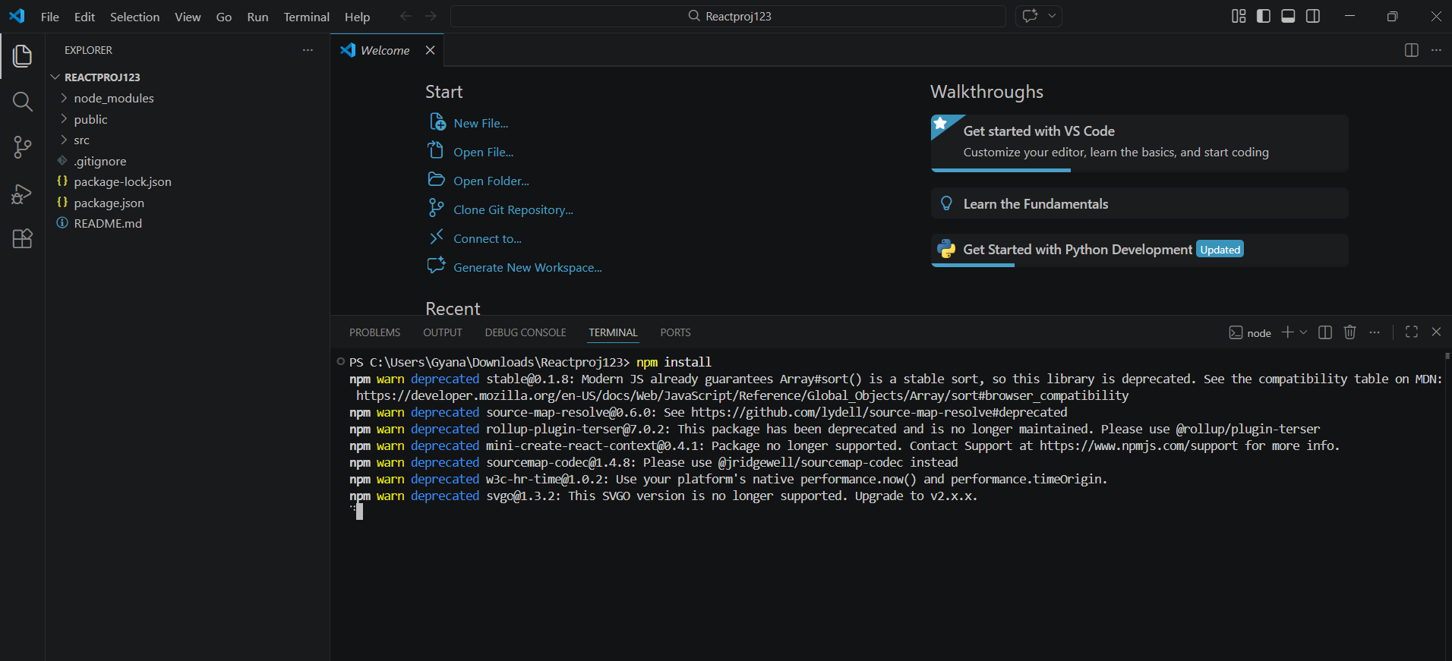
Step-3: Now run the build command using the npm run build.
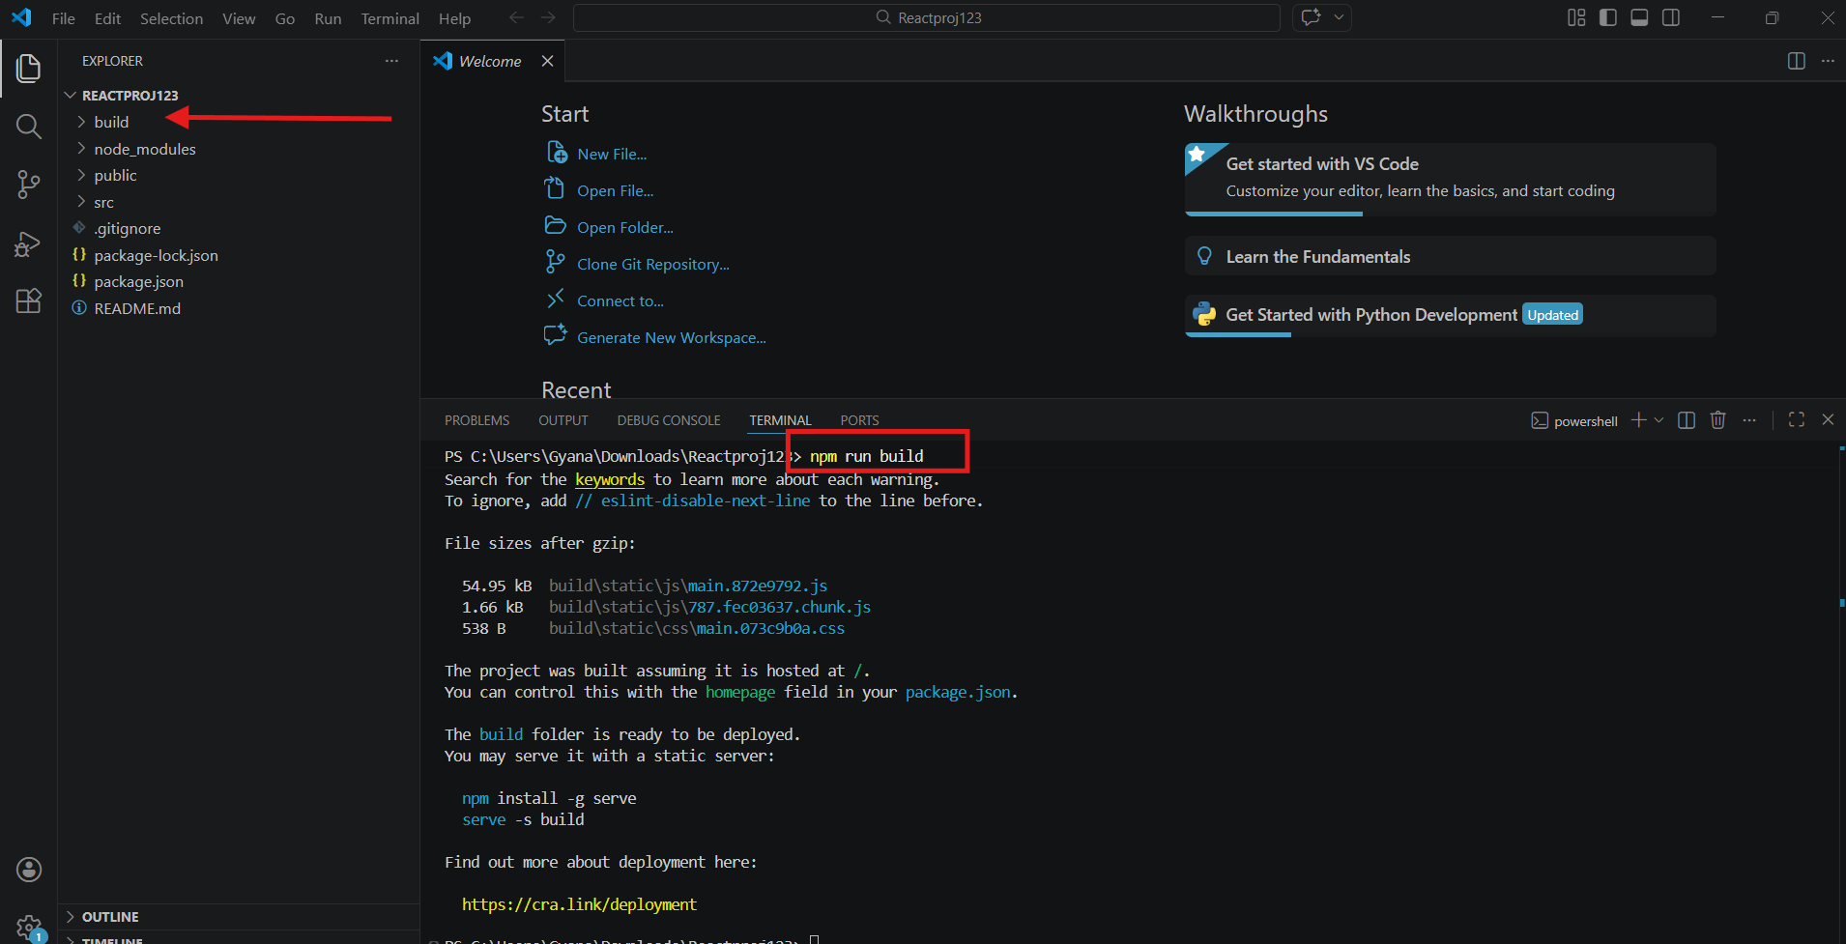
Step-4: Now start the project to host in browser : npm start (It will run on the port 3000)
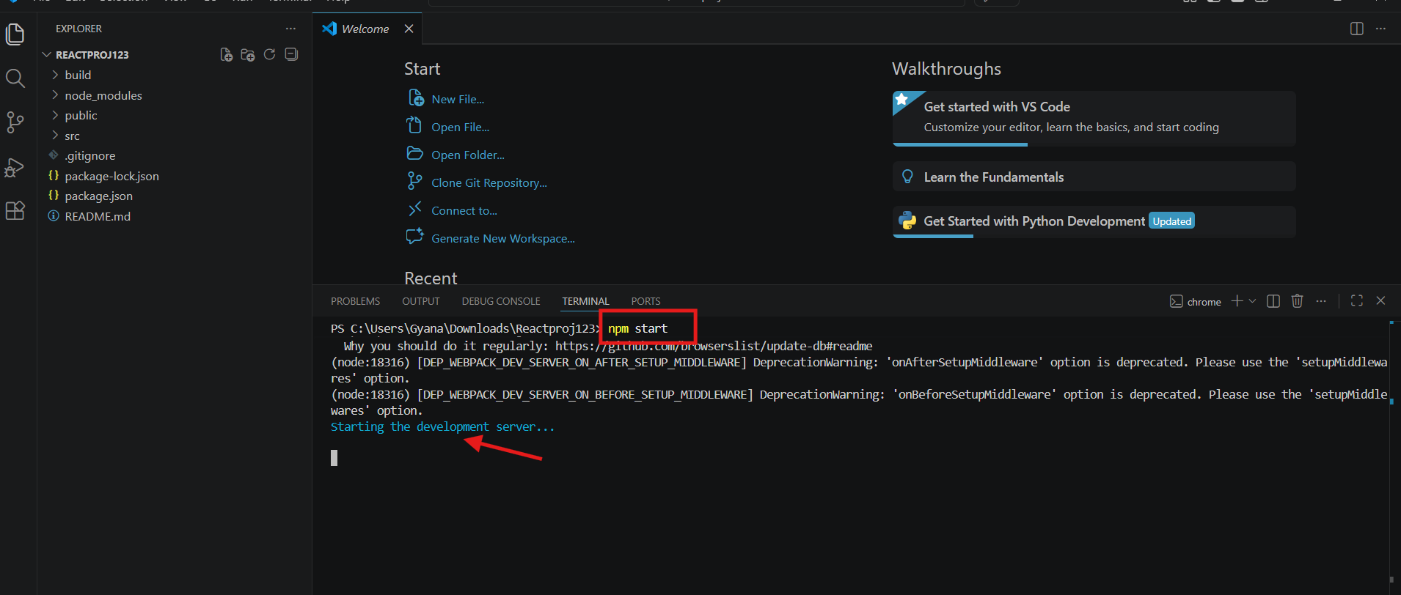
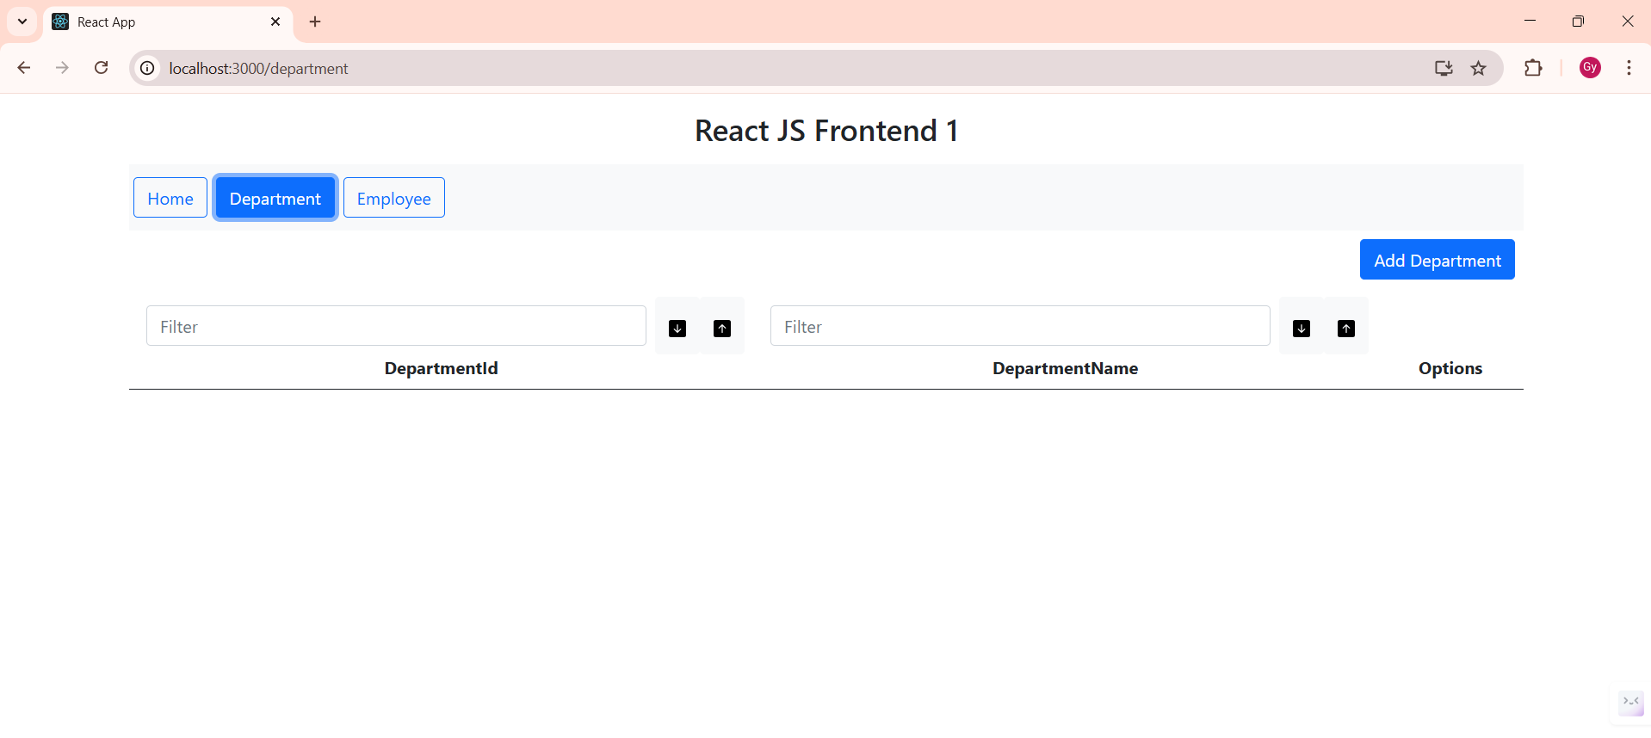
15. How do you document the deployment of a React application?
Step-1: Open your terminal inside the React project folder.
Step-2: Install the dependencies using npm install.
Step-3: Now run the build command using the npm run build.
Step-4: Now start the project to host in browser : npm start (It will run on the port 3000)

16. How do you deploy an Angular project?
- Sucessfully deployed
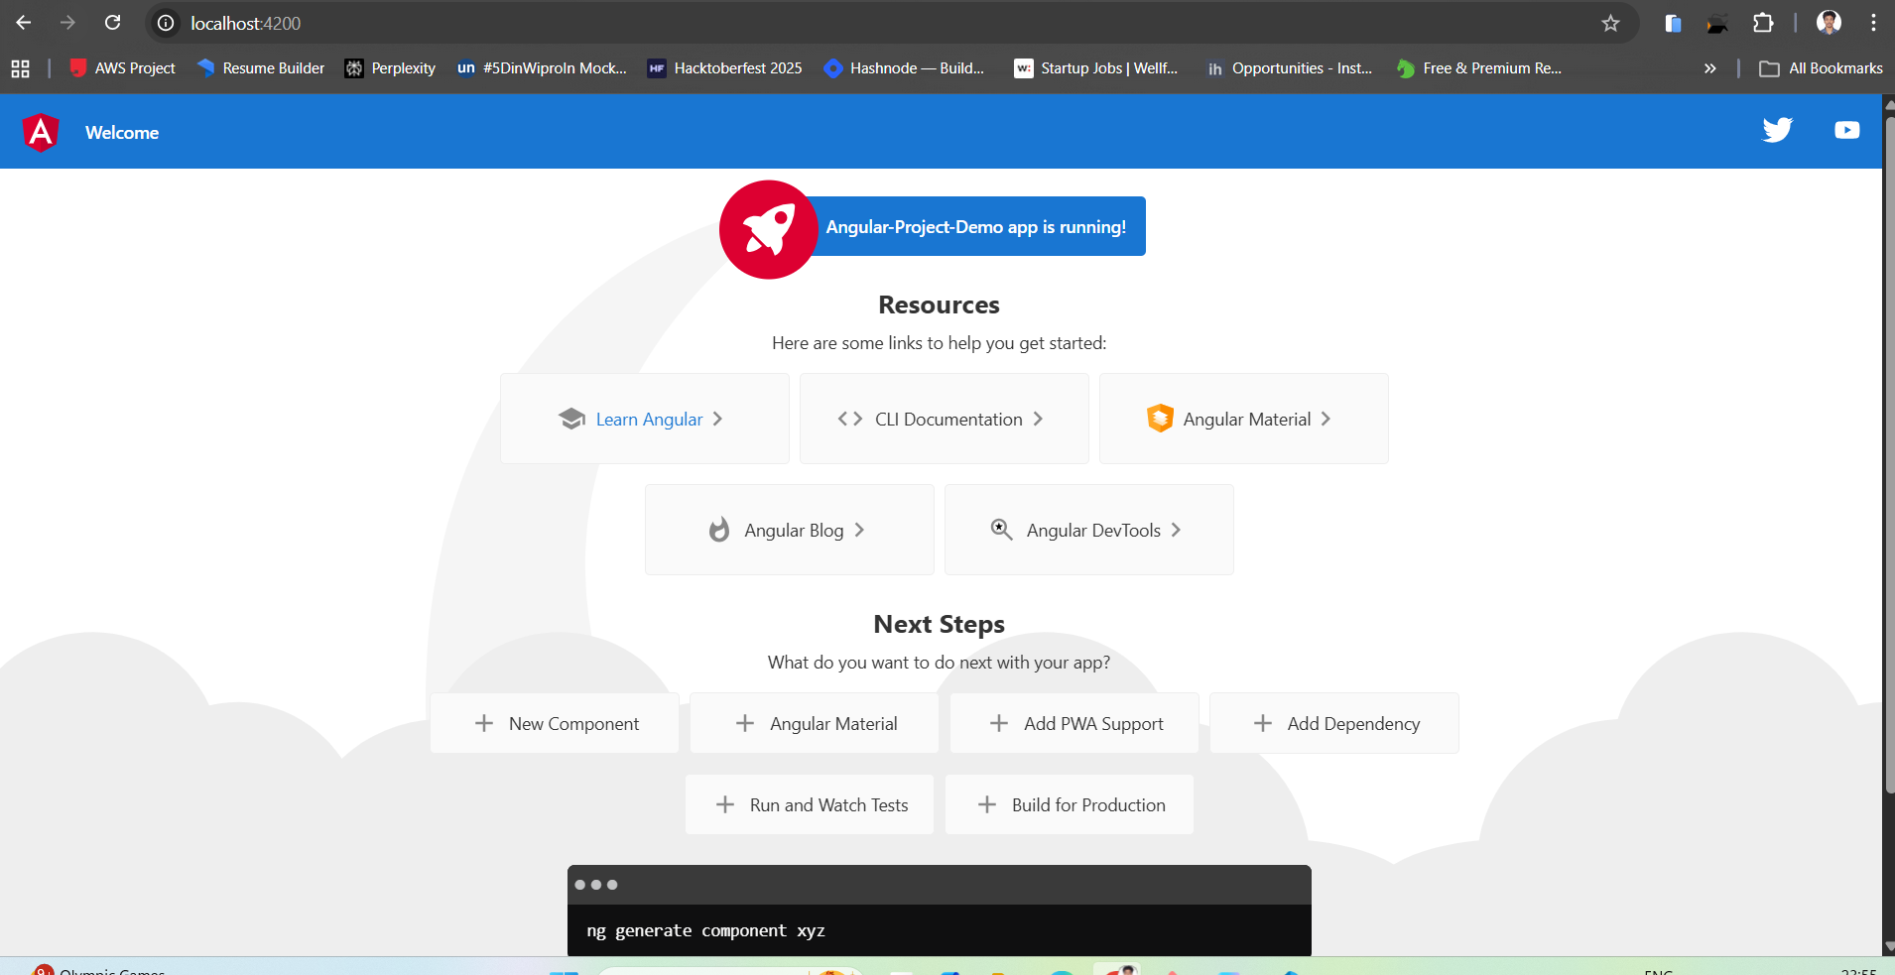
17. How do you document the deployment of an Angular application?
Step-1: Open the Angular Project in the VS-Code and in the terminal
Step-2: npm install - It will install the dependencies and will create a node_module folder
Step-3: npm run ng build : It will build the code and will create a dist folder.
Step-4: Now Start the project using npm start

18. How do you deploy a Vue.js application on an EC2 instance?
Step-1: Launch a Linux EC2 instance using Ubuntu AMI and connect via SSH.
Step-2: Update the ubuntu using sudo apt update.
Step-3: Install Node.js and Nginx on the instance: sudo apt install nginx nodejs npm.
Step-4: Clone the Vue project from GitHub and run npm install && npm run build.
Step-5: Move the generated dist/ folder contents to /var/www/html/.
Step-6: Edit the Nginx config (/etc/nginx/sites-available/default) to point to the files and restart Nginx: sudo systemctl restart nginx.

### Web App Deployment (Tomcat / EC2)
19. How do you deploy and run a web application on Apache Tomcat using an EC2 instance’s public IP?
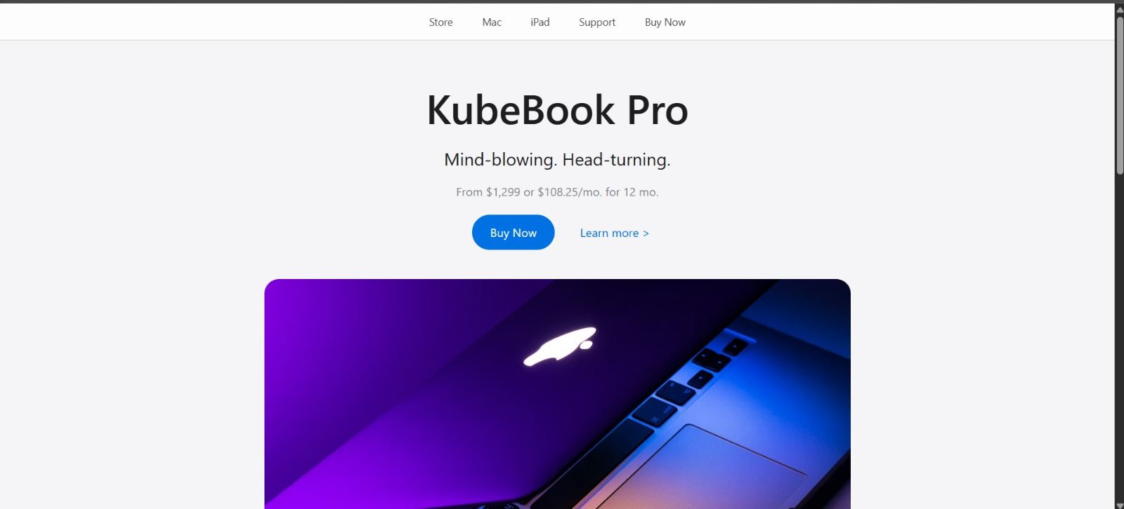

20. What are the steps to deploy a web application on Tomcat hosted on AWS EC2?
Phase 1: Prepare the AWS EC2 Instance
- Step-1: Launch an EC2 Instance: Launch a Linux instance (Ubuntu or Amazon Linux 2). Ensure the Security Group has Port 8080 (Tomcat's default) and Port 22 (SSH) open to IP.
- Step-2: Connect to Instance: Use SSH to log in: ssh -i .pem-file ec2-user@instance-public-dns.
- Step-3: Install Java: Tomcat requires Java.
Install it using: sudo apt update
sudo apt install openjdk-17-jdk -y (Ubuntu) or sudo yum install openjdk-17-jdk -y (Amazon Linux).
- Step-4: Install Tomcat: Download the latest Tomcat 10/11 version from the official website using wget, extract it using tar -xvf, and move it to /opt/tomcat.

Phase 2: Prepare the Web Application (WAR)
- Step-5: Clone the war application from the git hub to EC2 instance and run the maven build in codes mvn clean package
- Step-6: Locate the Build: Go to the target/ folder and find the my-webapp.war file

Phase 3: Deployment
- Step-7: Transfer the WAR file to tomcat: sudo cp /my-web-project/target/my-web-app.war /opt/tomcat/webapps
- Step-8: Start Tomcat: Navigate to the Tomcat bin folder and run the startup script: sudo sh /opt/tomcat/bin/startup.sh
- Step-9: Access the Application: Open the browser and navigate to: http://<EC2-Public-IP>:8080/my-web-app/

### Python / Django / Monitoring Apps
21. What are the steps to create and deploy a Django project?
Step-1: Create Project: Locally, install Django (pip install django), start a project (django-admin startproject myproject), and verify it runs with python manage.py runserver.
Step-2: Prepare for Production: In settings.py, set DEBUG = False and add the EC2 IP to ALLOWED_HOSTS. Create a requirements.txt file using pip freeze > requirements.txt.
Step-3: Set up EC2: Launch a Linux EC2, SSH into it, and install dependencies: sudo apt update && sudo apt install python3-pip python3-venv nginx -y
Step-4: Clone and VirtualEnv: Clone the repo, create a virtual environment (python3 -m venv venv), activate it, and install requirements (pip install -r requirements.txt).
Step-5: Nginx: Configure Nginx to proxy requests from Port 80

22. How do you host a Java monitoring application on an EC2 instance?
Step 1: Launch and Configure the EC2 Instance
- Launch Instance: Create a new EC2 instance (Ubuntu) using a .pem key file and ensure you allow HTTP requests.
- Get Public IP: Once the instance is running, copy its Public IPv4 address.
- Connect via SSH: Open MobaXterm and start a new SSH session.
  - Enter the Public IP in the Remote host field.
  - Set the username as ubuntu.
  - Under "Advanced SSH settings," upload your .pem security file.
  - Click OK to launch the server.
Step 2: Environment Setup and Project Cloning
- Clone the Project: Clone the repository from GitHub using the following command:
git clone https://github.com/gprasad-dev/Java-Monitoring-Project.git.
- Update System: Refresh the package index:
sudo apt update.
- Install Java: Install the OpenJDK 11 development kit and verify the version:
sudo apt install openjdk-11-jdk -y
java -version.
- Install Maven: Install Maven and verify the version:
sudo apt install maven -y
mvn -version.
Step 3: Build the Application
- Navigate to Project: Move into the cloned project directory: cd Java-Monitoring-Project/.
- Execute Maven Goals: Run the following sequence of commands to validate, compile, and test the code:
  - mvn validate
  - mvn compile
  - mvn test
- Package the App: Create the executable JAR file:
mvn package.
- Install Dependencies: Run the install goal to handle application dependencies:
mvn install.
Step 4: Run and Access the Application
- Navigate to Target: Move into the target folder where the build artifact is stored:
cd target.
- Launch the App: Run the JAR file using the Java command:
java -jar java-demoapp-1.0.0.jar.
- Configure Security Group: Go to the AWS Console for your EC2 instance and add an Inbound Rule for port 8080 to allow traffic.
- Access the App: Open a web browser and enter your instance IP followed by the port:
http://<EC2-INSTANCE-PUBLIC-IP>:8080.

23. How do you host a Python monitoring application on an EC2 instance?
Step-1: Launch EC2 Instance
- Launch an EC2 Instance using the Ubuntu AMI.
- Use an existing key pair (e.g., web-app.pem) for access.
- Ensure you allow HTTPS and HTTP traffic before launching the instance.
Step-2: Connect to the VM
- Open MobaXterm and connect to the virtual machine using its Public-IP and your Private Key.
Step-3: Clone the Project
- Clone the Python Monitoring Project from the central GitHub repository.
- Navigate into the project folder and run sudo apt update to refresh the package list.
Step-4: Set up the Environment
- Navigate into the src folder.
- Install the virtual environment package: sudo apt install python3.12-venv.
- Create the virtual environment: python3 -m venv venv.
- Activate the environment: source venv/bin/activate.
Step-5: Install Dependencies and Test
- Install the required project dependencies.
- Run tests using pytest to verify the code and dependencies: pytest -v.
Step-6: Run the Application
- Start the project: python run.py.
- The application will run on port 5000.
Step-7: Configure Security and Access
- Go to the Security groups of your EC2 Instance and allow the necessary Inbound Rules for the application port.
- Save the rules.
- Access the application in your browser using the Public-IP:5000 (e.g., 65.0.129.181:5000).
Step-8: Stop and Deactivate
- Stop the application hosting when finished.
- Deactivate the virtual environment using the deactivate command.

